Experiment-11
AIM: Simulate dilation, erosion, opening and closing operation on images.

Theory:
Dilation, erosion, opening, and closing are morphological operations used in image processing to manipulate the shape and size of objects in an image.
Dilation:
Dilation expands the boundaries of objects in an image by adding pixels to the object's boundaries. It is achieved by sliding a structuring element over the image and assigning the maximum pixel value within the neighborhood of each pixel.
Erosion:
Erosion shrinks the boundaries of objects in an image by removing pixels from the object's boundaries. It is achieved by sliding a structuring element over the image and assigning the minimum pixel value within the neighborhood of each pixel.
Opening:
Opening is an erosion operation followed by a dilation operation. It is used to remove noise and small objects from the image while preserving the larger objects' shapes.
Closing:
Closing is a dilation operation followed by an erosion operation. It is used to close small gaps and holes within objects while preserving the overall object shapes.

Image used: A picture of two Indian vehicle number plates (images.jpg). The plates have dark characters on a white background, so after thresholding the characters, borders and logo form clear white objects of different thickness. This makes the effect of each operation easy to see.

Program
import cv2
import numpy as np
import matplotlib.pyplot as plt

# Load the image as grayscale
image = cv2.imread('images.jpg', 0) # Replace with your image path

# Convert to binary image (characters become white objects on black background)
_, binary = cv2.threshold(image, 0, 255, cv2.THRESH_BINARY_INV + cv2.THRESH_OTSU)

# Define the kernel (structuring element)
kernel = np.ones((5, 5), np.uint8)

# Perform Erosion
erosion = cv2.erode(binary, kernel, iterations=1)

# Perform Dilation
dilation = cv2.dilate(binary, kernel, iterations=1)

# Perform Opening (Erosion followed by Dilation)
opening = cv2.morphologyEx(binary, cv2.MORPH_OPEN, kernel)

# Perform Closing (Dilation followed by Erosion)
closing = cv2.morphologyEx(binary, cv2.MORPH_CLOSE, kernel)

# Number of white (object) pixels in each image
print("Binary image :", np.count_nonzero(binary))
print("Erosion :", np.count_nonzero(erosion))
print("Dilation :", np.count_nonzero(dilation))
print("Opening :", np.count_nonzero(opening))
print("Closing :", np.count_nonzero(closing))

# Display the original image and the results
images = [image, binary, erosion, dilation, opening, closing]
titles = ['Original Image', 'Binary Image', 'Erosion', 'Dilation', 'Opening', 'Closing']

plt.figure(figsize=(12, 7))
for i in range(6):
plt.subplot(2, 3, i + 1)
plt.imshow(images[i], cmap='gray')
plt.title(titles[i])
plt.axis('off')
plt.tight_layout()
plt.show()

Output:-
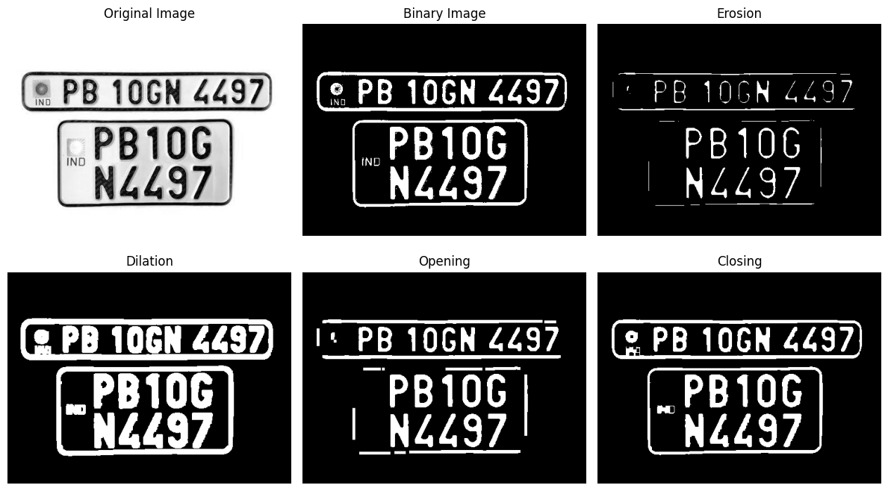

Binary image : 25690
Erosion : 8507
Dilation : 44054
Opening : 23290
Closing : 26582

Observations:-
Binary image: The image is converted to a binary image with Otsu thresholding, so that the characters, plate borders and logo are white objects (25690 white pixels) on a black background.
Erosion: The white objects shrink. The white pixels decrease from 25690 to 8507 (about 67 % less). The characters and borders become thinner and the thin parts of the plate border are broken.
Dilation: The white objects grow. The white pixels increase from 25690 to 44054 (about 71 % more). The characters and borders become thicker, and the small gaps between them become smaller.
Opening: Small and thin objects, such as the logo and the small "IND" text, are removed, while the thick characters keep their shape and size. The white pixels decrease only by about 9 % (23290), much less than for erosion alone. Some thin parts of the plate border are also removed.
Closing: Small gaps and holes are filled, so the logo and the "IND" text become filled blobs, while the overall shape of the characters and borders is preserved. The white pixels increase only by about 3.5 % (26582), much less than for dilation alone.

Conclusion
Dilation and erosion change the size of the objects in an image, and the structuring element decides how much. Opening removes small and thin objects without changing the size of the large objects much, and closing fills small holes and gaps without changing the overall shape. Therefore, opening is useful for noise removal and closing is useful for joining broken parts of an object.

